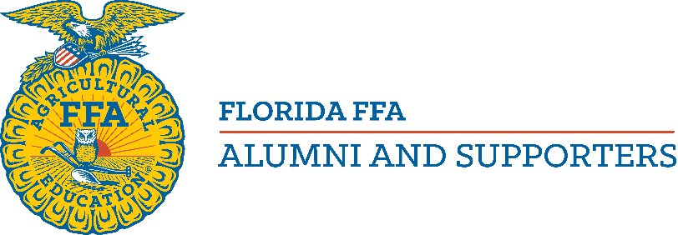

Florida FFA Alumni Council Nomination Form

- Email completed form to archielmatthews@gmail.com. You may also deliver this application to the convention registration desk or Alumni Central during State FFA Convention by 6:00pm. June 21, 2023. Elections will occur during the state business meeting June 23, 6:30 pm. Please type or write legibly!

Applicant’s Name:
Physical Address:
Email Address: Phone #:
Desired Position: Nominated By:
Local Alumni Chapter: Number of Years as a Member:

Please answer the following questions on additional pages.
- List your Alumni & Supporter activities (include local, state and national levels).
- Please list any outstanding achievements and community activities.
- Why do you want to serve on the Florida FFA Alumni and Supporters Council?
- If elected to serve as a council member, how will you communicate with local chapters?

FLORIDA FFA ALUMNI & SUPPORTERS
DIRECTOR and DIRECTOR AT LARGE DUTIES

- Represent Florida FFA Alumni at State functions as requested.
- Be knowledgeable of the State and National Alumni structure and guidelines.
- Sell State Alumni Raffle Tickets along with distributing tickets to Chapters within your area.
- Communicate with local Alumni Chapters to share State and National Alumni updates.
- Assist local Alumni Chapters, as needed, with questions or issues that may arise.
- Attend local Alumni meetings within your District as requested.
- Volunteer to work shifts at the Alumni area at the State Convention Expo.
- Attend State Alumni Conference and four Quarterly State Alumni Meetings.
- Assist local Chapters that want to reactive or charter a new Alumni.
- Provide a report of District activities at quarterly Board meetings.

I have read and fully understand what the expectations are for me as a Florida Alumni & Supporters Director. If, at any time, I am not able to fulfill these duties I will advise the State Alumni President so that a replacement can be found.

Name:

Signature: Date:

Revised 5/4/2023

